# React Note

* // eslint-disable-next-line 🡪 whenever getting warning in using useEffect for not having dependency then use this line to make the warning disappear

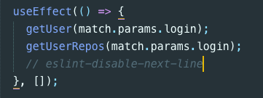

*CSS:*

<https://css-tricks.com/guides/> 🡪 có nhiều links để coi trong này, all complete guides

* rem, em la gi

## *To-do:*

* React-router-dom
  + Link
  + Router
  + Switch
  + route
* Cần improve CSS, HTML – so gonna search for links and articles for CSS and HTML to practice and build a strong base